Mockito Advanced Exercises

Name: Shubham Sangram Bej

Aim
To implement advanced unit testing techniques using Mockito by mocking repositories, REST clients, file operations, network interactions, and multiple return values while validating application logic using JUnit 5.

Objectives
- Learn repository mocking.
- Mock external REST services.
- Simulate file input/output.
- Mock network interactions.
- Implement multiple return values.
- Improve software testing using Mockito.

Software Requirements
- Java JDK 21
- IntelliJ IDEA
- Apache Maven
- Mockito
- JUnit 5
- Git
- GitHub

Theory
Mockito is a Java mocking framework that allows developers to isolate application components by replacing external dependencies with mock implementations. It enables fast, reliable, and maintainable unit tests by simulating repositories, APIs, file systems, and network resources.

Advantages
- Fast unit testing
- Independent of external systems
- Easy stubbing
- Flexible verification
- Better maintainability

Exercises Performed

Exercise 1 – Mocking Databases and Repositories

Description
A mock repository was created to simulate database access. Repository methods were stubbed to return predefined data, and the service processed the mocked response successfully.
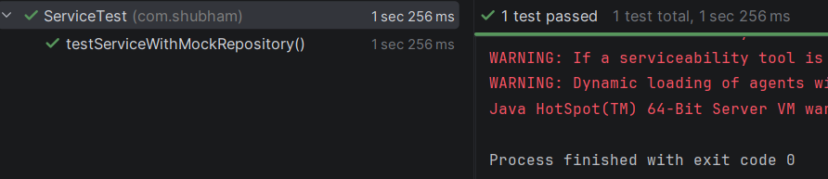

Exercise 2 – Mocking External Services

Description
A mock REST client simulated API responses. The service successfully fetched mocked data without making actual network requests.
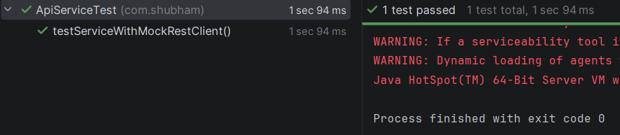

Exercise 3 – Mocking File I/O

Description
Mock implementations of file reader and file writer simulated file operations. Mockito verified that the write operation was executed correctly.
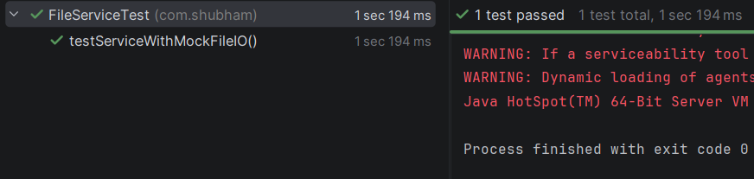

Exercise 4 – Mocking Network Interactions

Description
A mock network client simulated server connectivity. The service verified successful interaction using mocked responses.
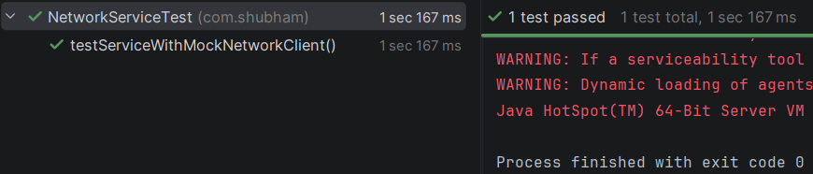

Exercise 5 – Mocking Multiple Return Values

Description
Mockito was configured to return different values on consecutive method calls using chained thenReturn() statements.
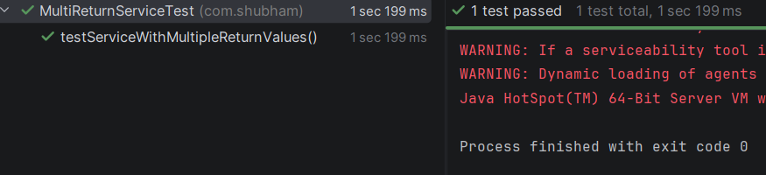

Project Structure

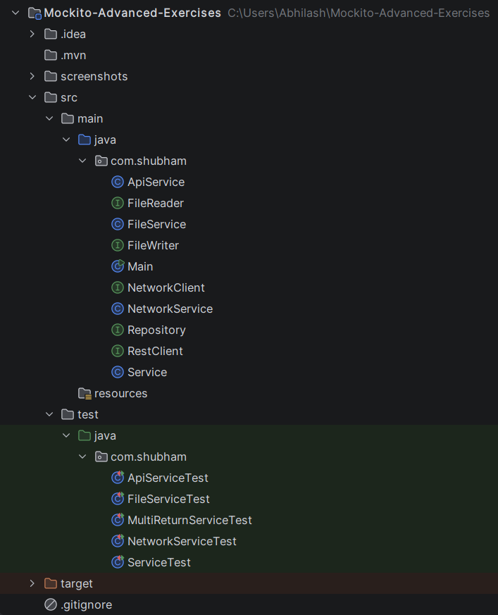

Results
Successfully implemented:
- Repository mocking
- REST API mocking
- File I/O mocking
- Network mocking
- Multiple return values
- JUnit 5 integration
- Mockito stubbing and verification
All test cases passed successfully.

Conclusion
The Advanced Mockito exercises demonstrated how to isolate application logic from external systems using mock objects. Repository, REST API, file system, and network interactions were simulated effectively, allowing comprehensive testing without relying on real resources. Mockito significantly improves unit testing quality and application reliability.

References
- Mockito Documentation – https://site.mockito.org/
- JUnit 5 User Guide – https://junit.org/junit5/docs/current/user-guide/
- Apache Maven Documentation – https://maven.apache.org/
- Oracle Java Documentation – https://docs.oracle.com/en/java/

